For Uniform Inter-arrival rate:

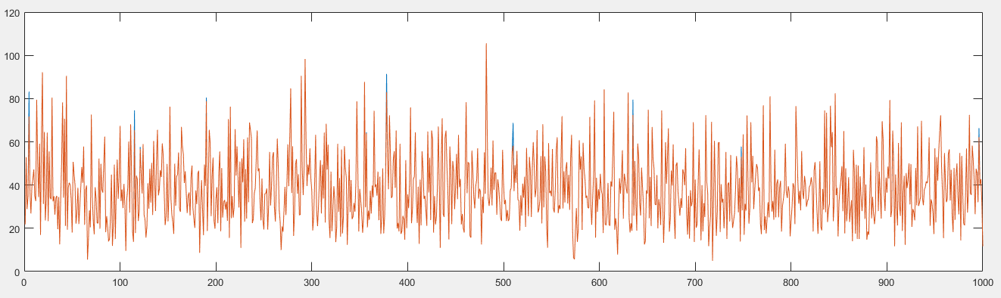

Setting: Inter-arrival rate: Uniform(180-220), basic service Time=Exponential(100)

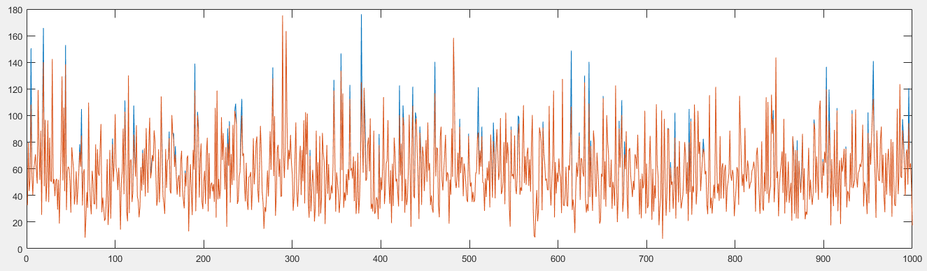

Setting: Inter-arrival rate: Uniform(180-220), basic service Time=Exponential(150)

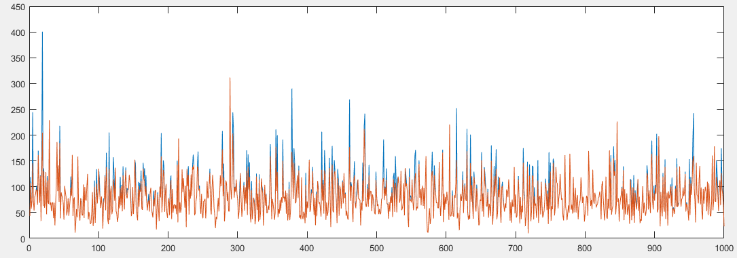

Setting: Inter-arrival rate: Uniform( 180-220), basic serviceTIme=Exponential(200)

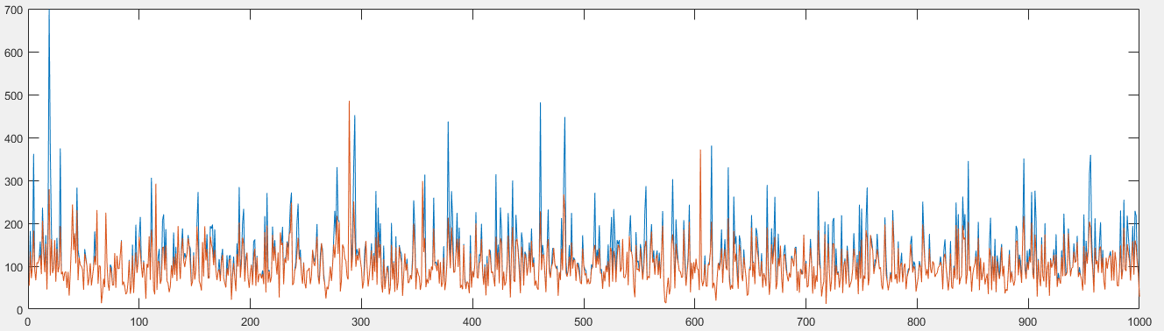

Setting: Inter-arrival rate: Uniform(180-220), basic service time=Exponential(250)

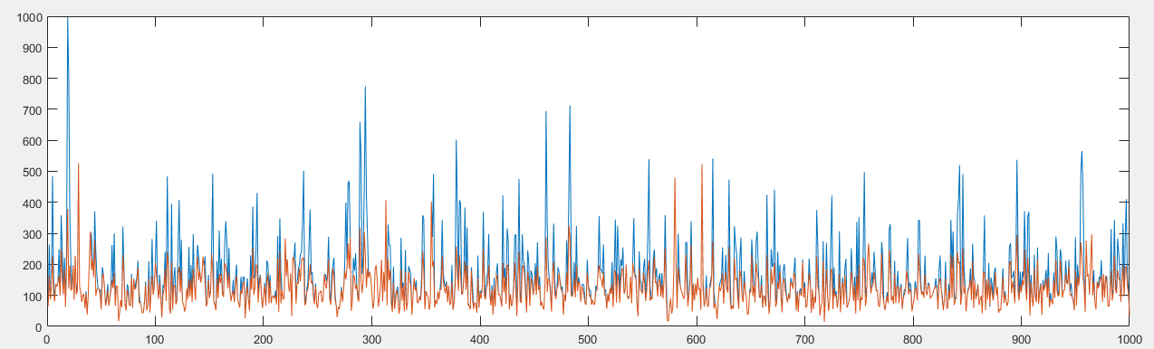

Setting: Inter-arrival rate=Uniform(180-220), basic service Time=Exponential(300)

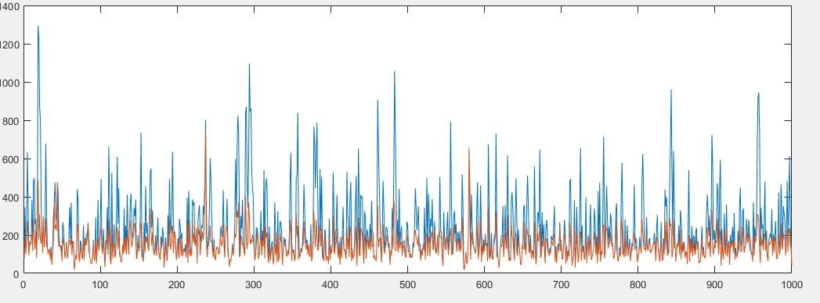

Setting: Inter-arrival rate=Uniform(180-220), basic serviceTime=Exponential(350)

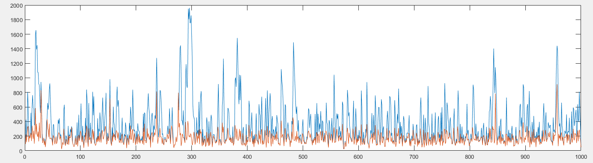

Setting: Inter-arrival rate=Uniform(180-220), basic ServiceTime=Exponential(400)

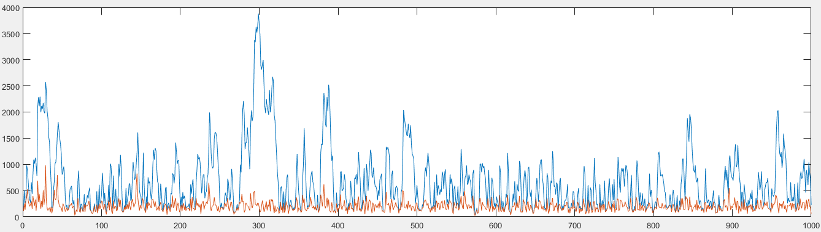

Setting: Inter-arrival rate=Uniform(180-220), basic ServiceTime=Exponential(450)

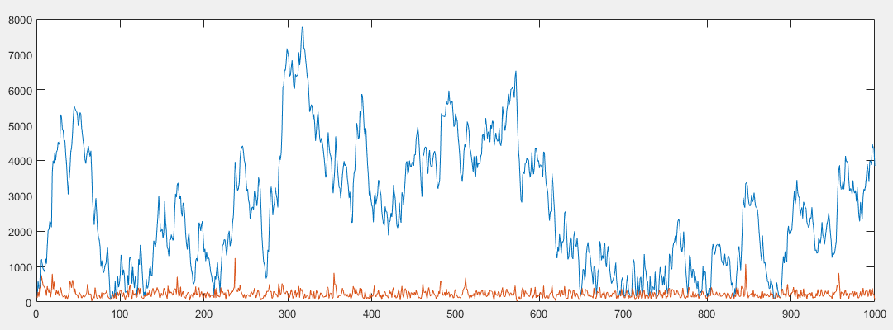

Setting: Inter-arrival rate=Uniform(180-220), basic serviceTime=Exponential(500)

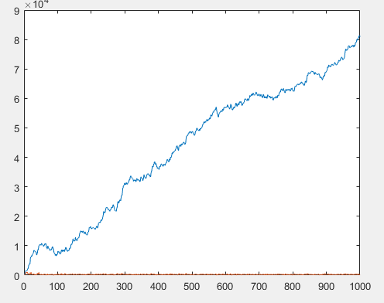

Setting: Inter-arrival rate=Uniform(180-220), basic serviceTime=Exponential(550)

Now, for Inter-arrival rate of Uniform(70-130)

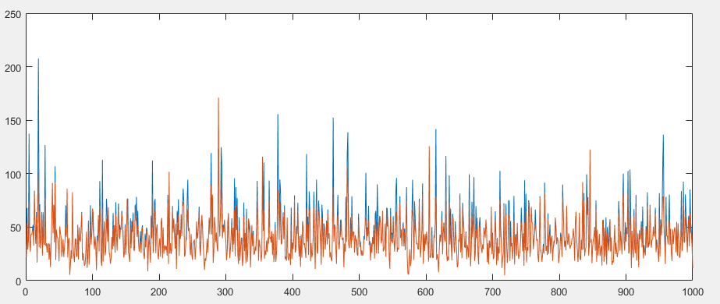

Basic serviceTime=Exponential(100)

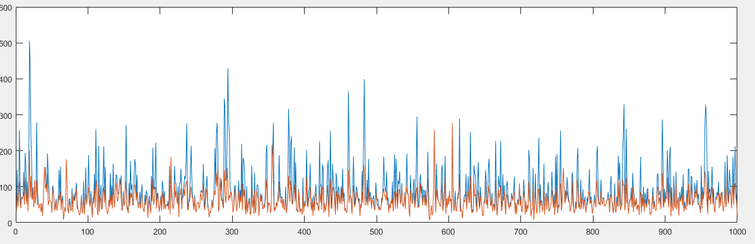

Basic ServiceTime=Exponential(150)

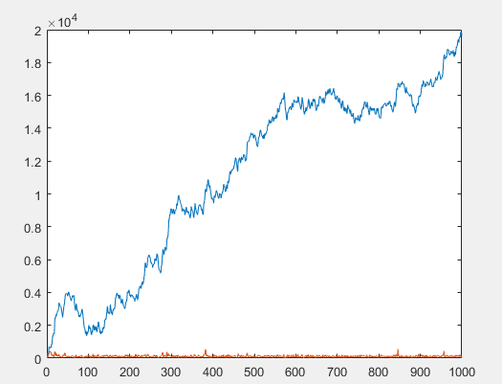v

Basic serviceTime=Exponential(250)

The trend is similar for various inter-arrival rates distributed uniformly.

Now, for differently distributed basic serviceTime

For Inter-arrival rate which is uniformly distributed as Uniform(70,130)

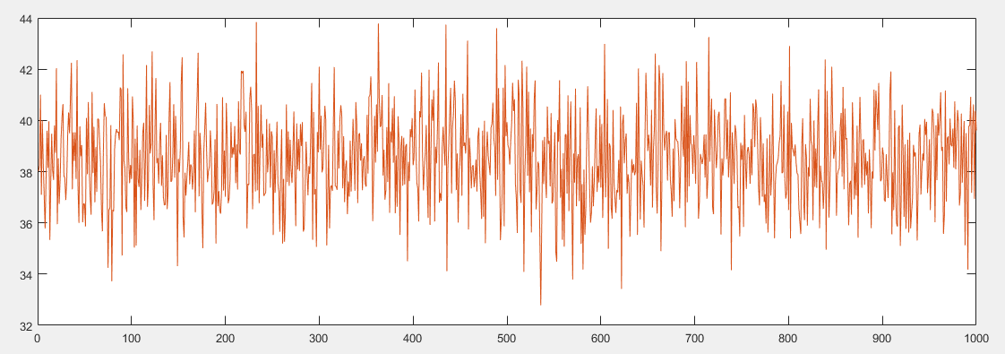

Basic ServiceTime=Erlang(100,1)

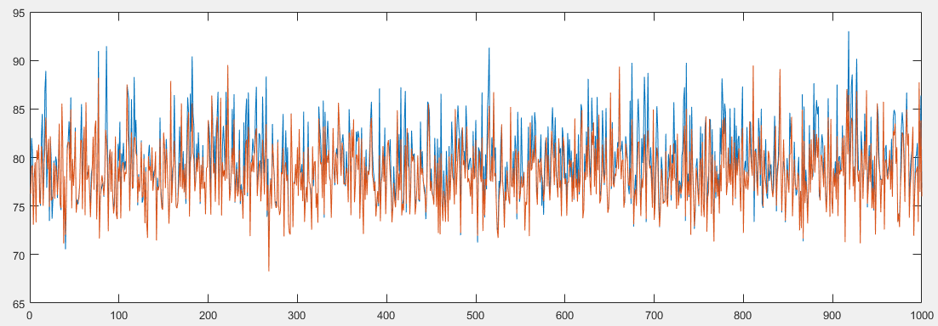

Basic ServiceTime=Erlang(200,1)

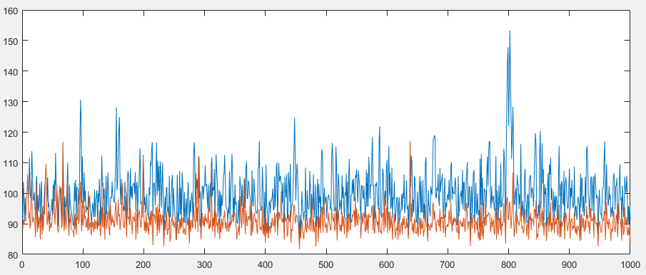

Basic ServiceTime=Erlang(230,1)

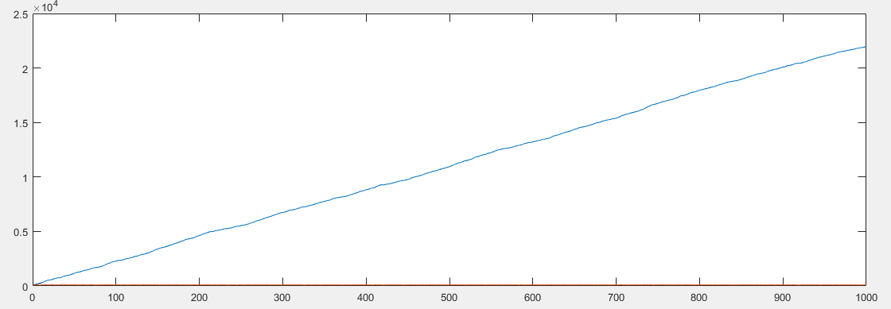

Basic ServiceTime=Erlang(250,1)

For inter-arrival rate of Uniform(170,230)

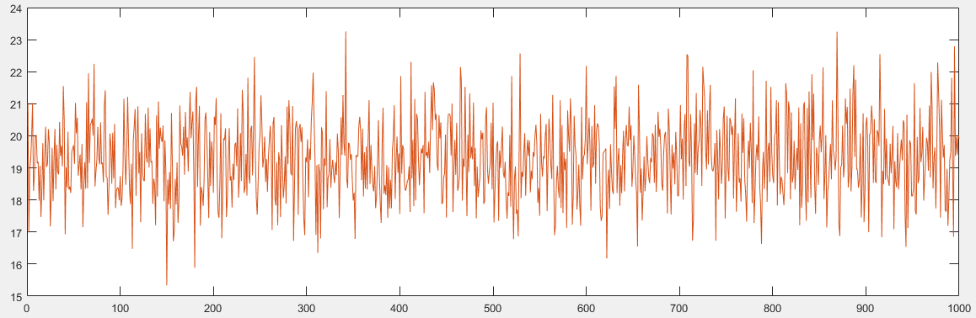

Basic ServiceTime=Erlang(50,1)

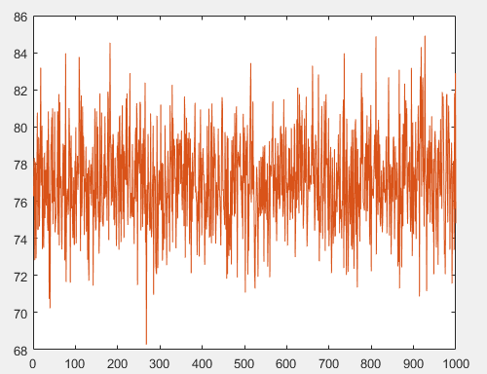

Basic ServiceTime=Erlang(200,1)

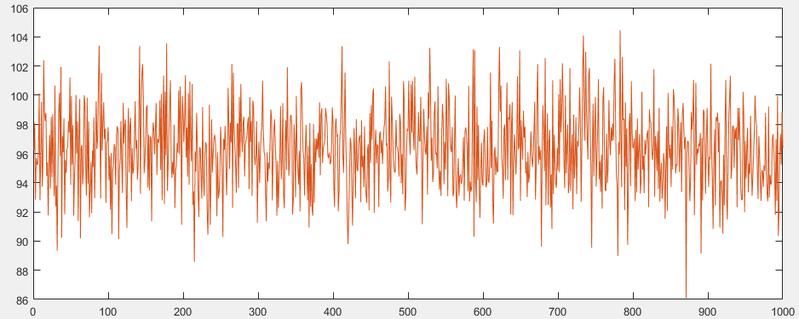

Basic ServiceTime=Erlang(250,1)

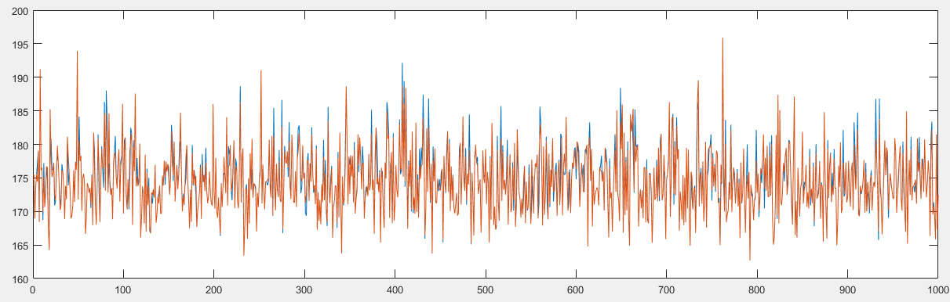

Basic ServiceTime=Erlang(450,1)

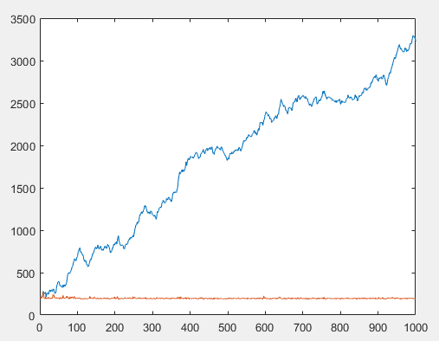

Basic ServiceTime=Erlang(500,1)

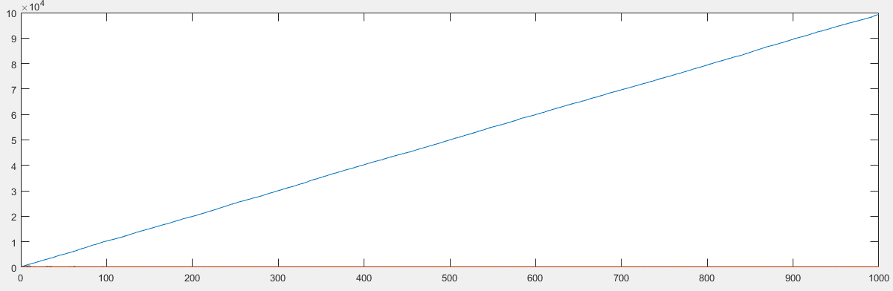

Basic ServiceTime=Erlang(550,1)

Inter-arrival rate : Uniform (170,230)

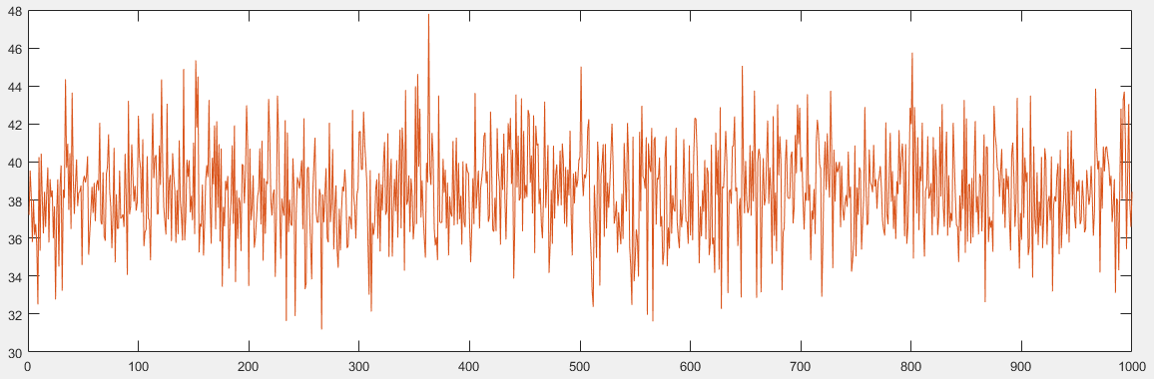

Basic ServiceTime=Chisquare(100)

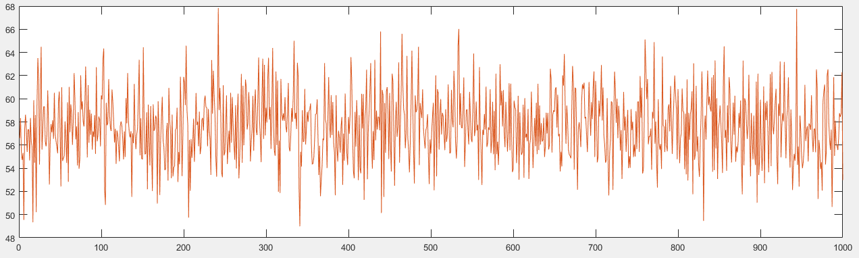

Basic ServiceTime=Chisquare(150)

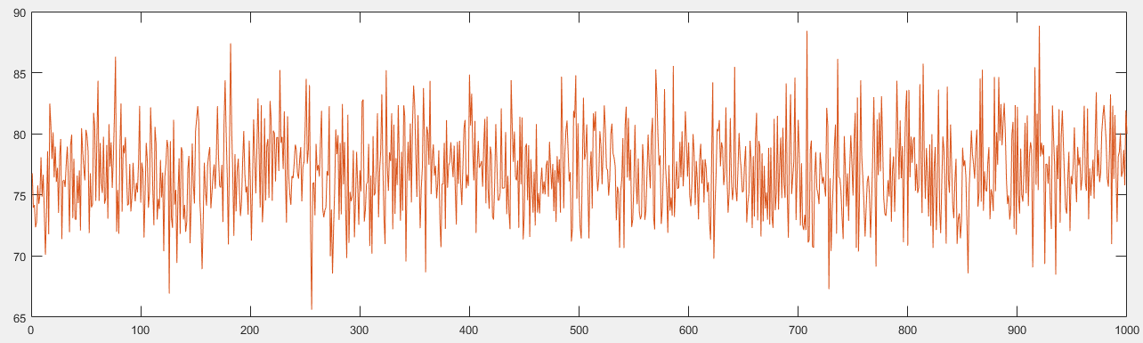

Basic ServiceTime=Chisquare(200)

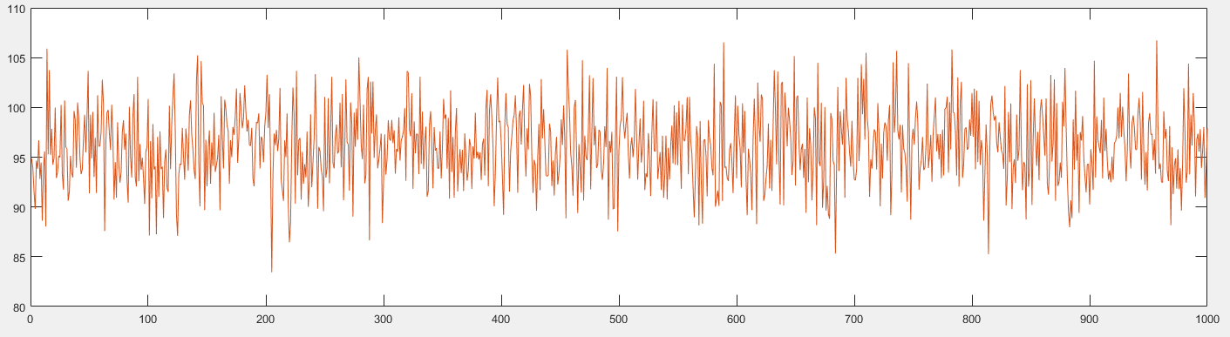

Basic ServiceTime=Chisquare(250)

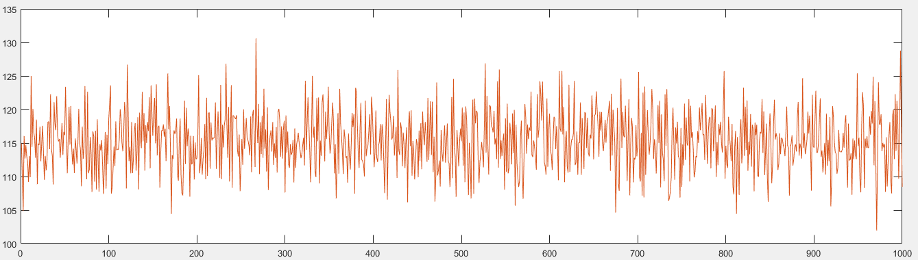

Basic ServiceTime=Chisquare(300)

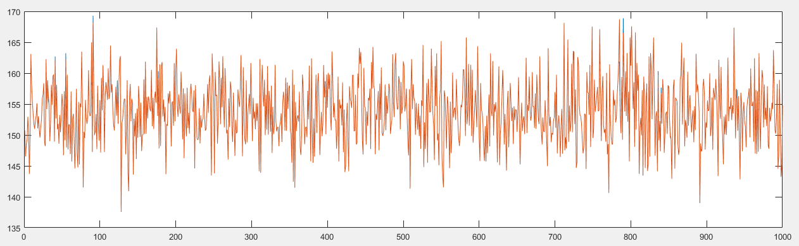

Basic ServiceTime=Chisquare(400)

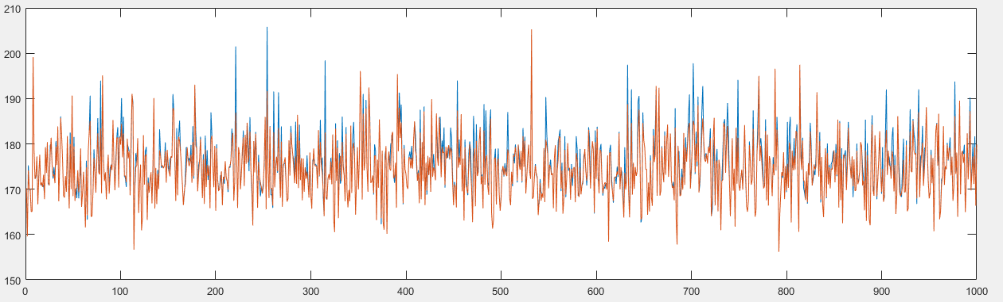

Basic ServiceTime= Chisquare(450)

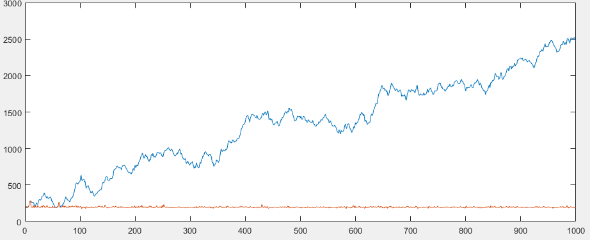

Basic ServiceTime=Chisquare(500)

For Inter-arrival rate: Uniform(70,130)

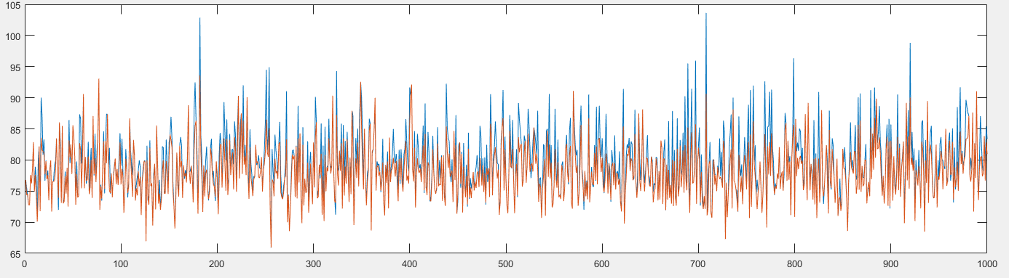

Basic ServiceTime=Chisquare(100)

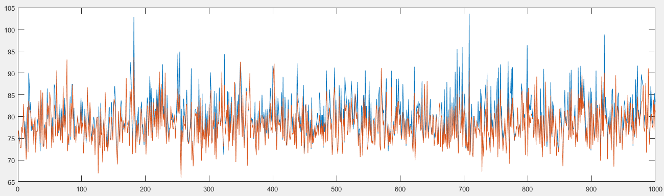

Basic ServiceTime=Chisquare(200)

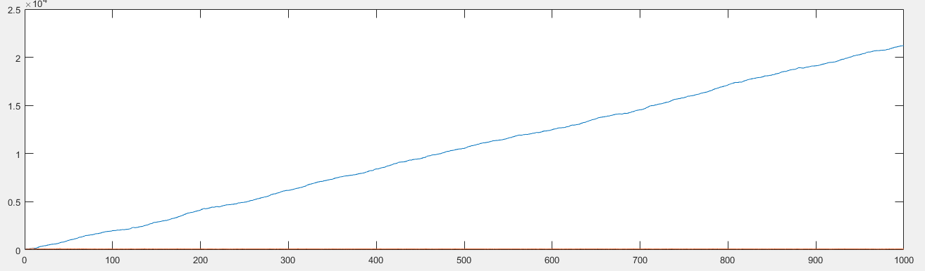

Basic ServiceTime=Chisquare(250)

\*\*\*\*\*\*\*\*\*\*\*\*\*\*\*\*\*\*\*\*\*\*\*\*\*\*\*\*\*\*\*\*\*\*\*\*\*\*\*\*\*\*\*\*\*\*\*\*\*\*\*\*\*\*\*\*\*\*\*\*\*\*\*\*\*\*\*\*\*\*\*\*\*\*\*\*\*\*\*\*\*\*\*\*\*\*\*\*\*\*\*\*\*\*\*\*\*\*\*\*\*\*\*\*\*\*\*\*\*\*\*\*\*\*\*\*\*\*\*\*\*\*\*\*\*\*\*\*\*\*\*\*\*\*\*\*\*\*\*\*\*\*\*\*\*\*\*\*\*\*\*\*\*\*\*\*\*\*\*\*\*\*\*\*\*\*\*\*\*\*\*\*\*\*\*\*\*\*\*\*\*\*\*\*\*\*\*\*\*\*\*\*\*\*\*\*\*\*\*\*\*\*\*\*\*\*\*\*\*\*\*\*\*\*\*\*\*\*\*\*\*\*\*\*\*\*\*\*\*\*\*\*\*\*\*\*\*\*\*\*\*\*\*\*\*\*\*\*\*\*\*\*\*\*\*

Inter-arrival rate of Uniform(170,230)

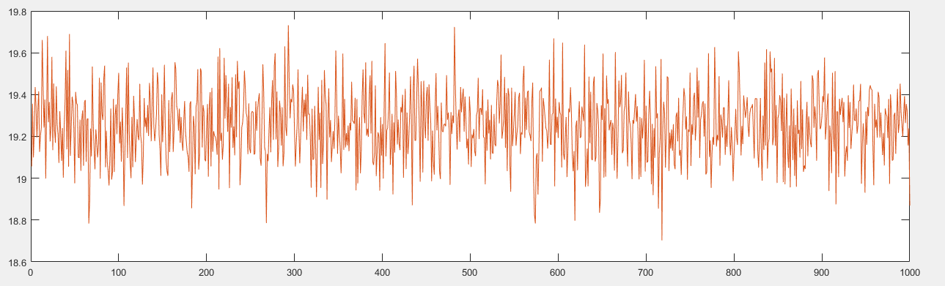

Basic ServiceTime=Normal (50,1)

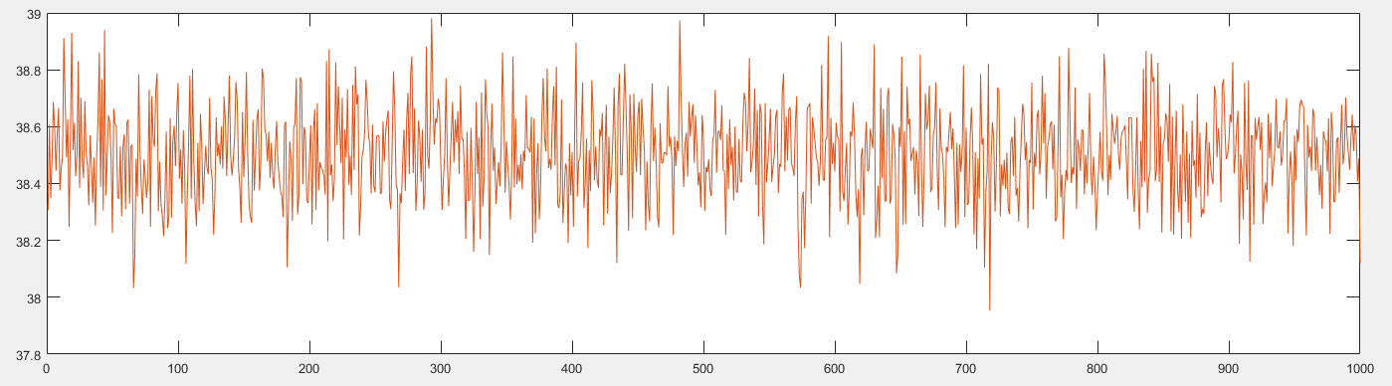

Basic serviceTime=Normal(100,1)

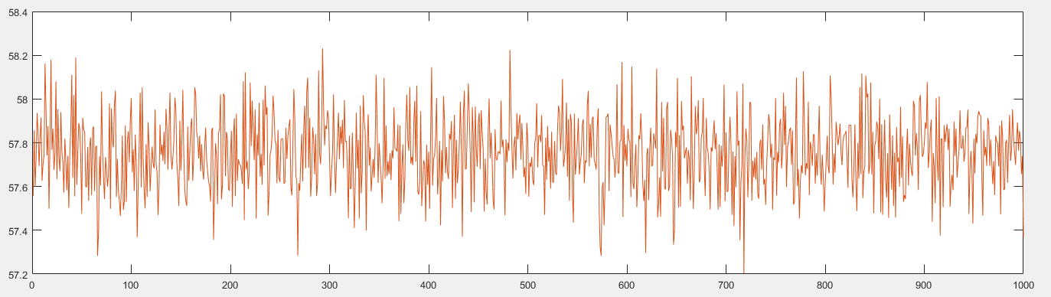

Basic ServiceTime=Normal(150,1)

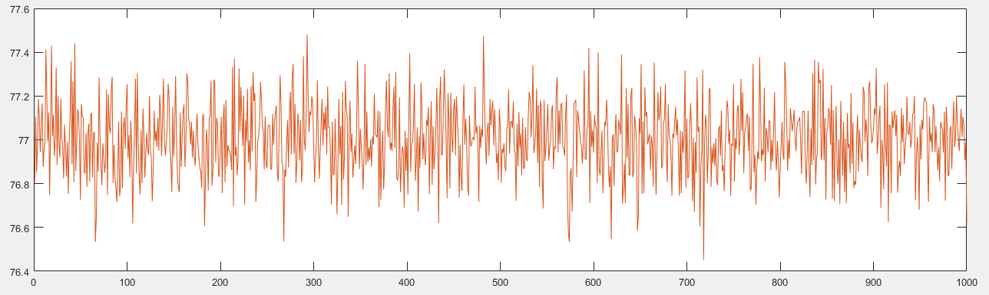

Basic ServiceTime=Normal(200,1)

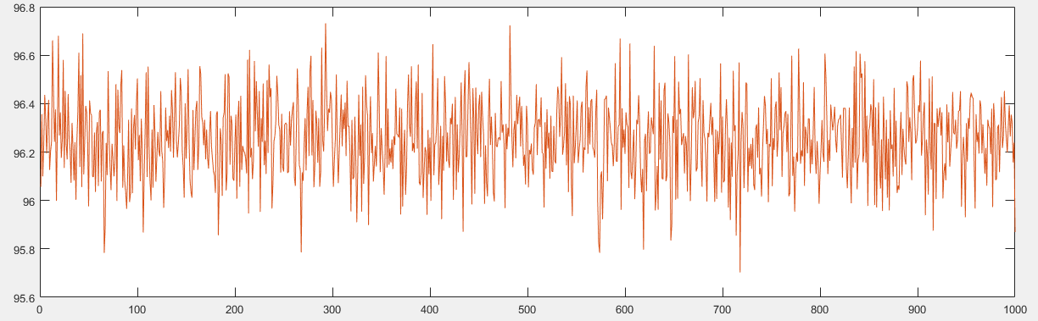

Basic ServiceTime=Normal(250,1)

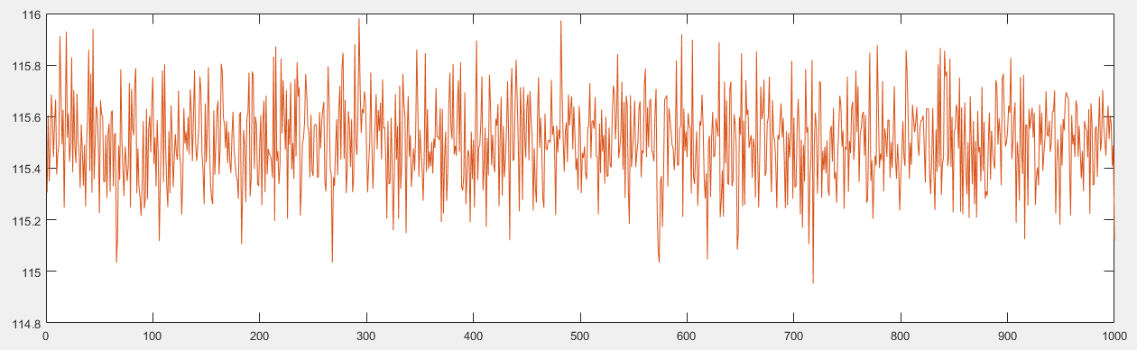

Basic ServiceTime=Normal(300,1)

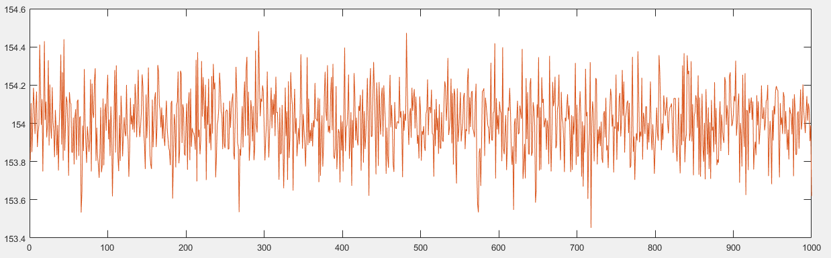

Basic ServiceTime=Normal(400,1)

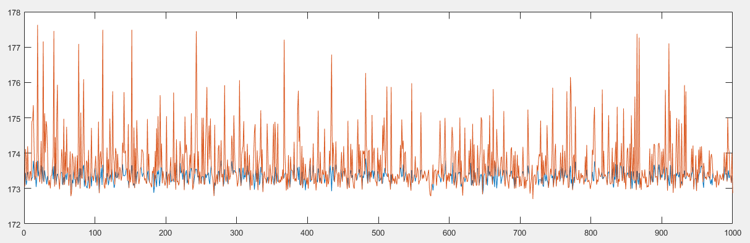

Basic ServiceTime=Normal(450,1)

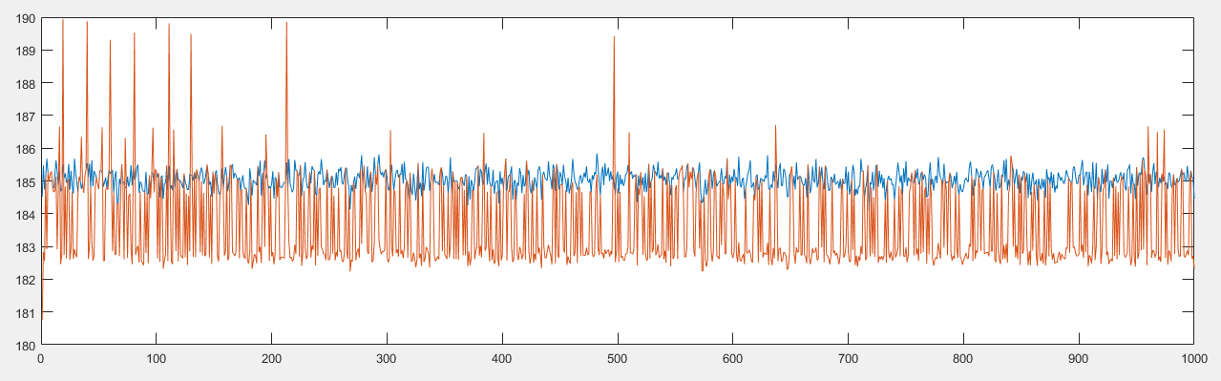

Basic ServiceTIme=Normal(470,1)

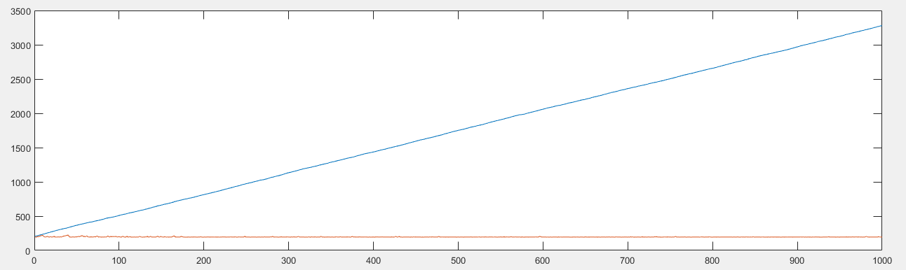

Basic ServiceTime=Normal(500,1)

Inter-arrival Rate: Uniform(70,130)

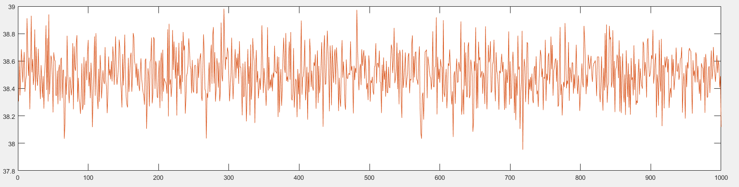

Basic ServiceTime=Normal(100,1)

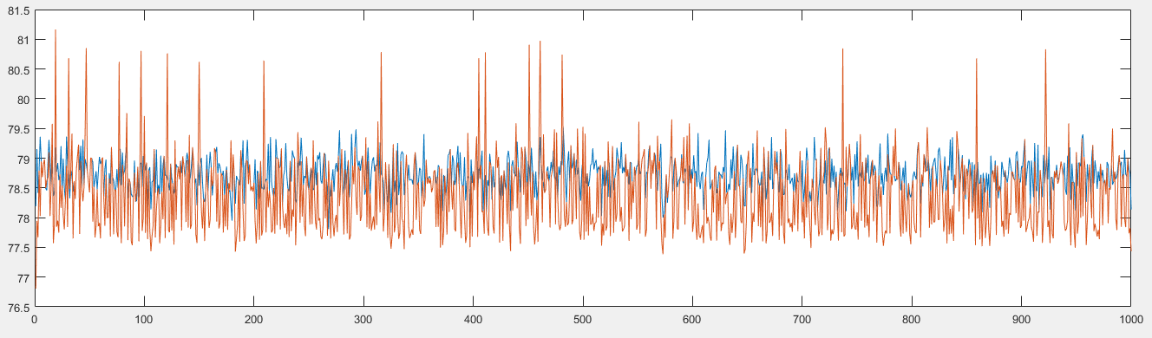

Basic serviceTime=Normal(200,1)

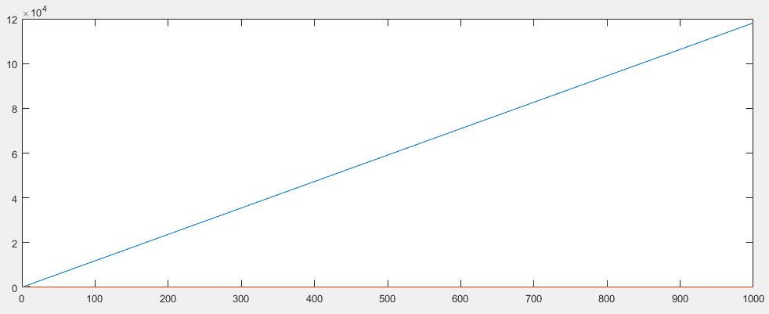

Basic ServiceTime=Normal(250,1)

For Uniform Inter-arrival rate of (170,230)

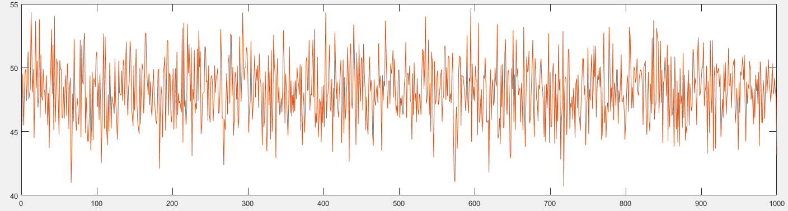

Basic ServiceTime = uniform(100,150)

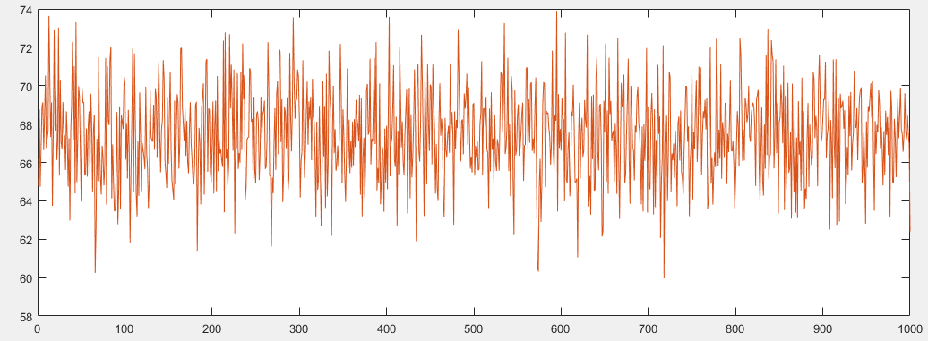

Basic ServiceTime=Uniform(150,200)

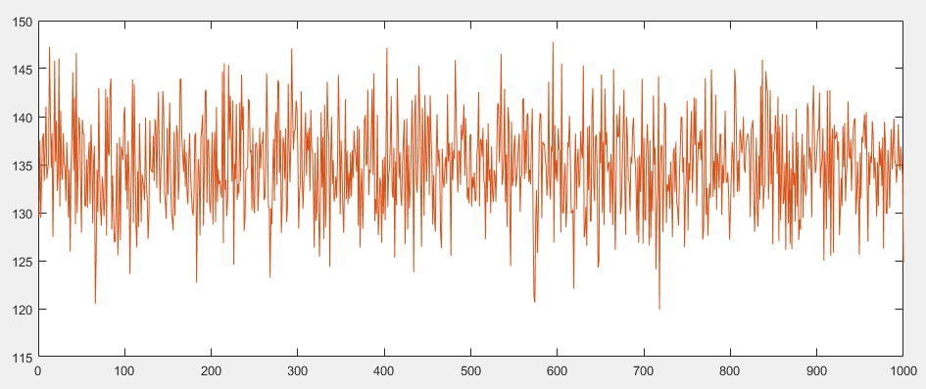

Basic ServiceTIme=Uniform(300,350)

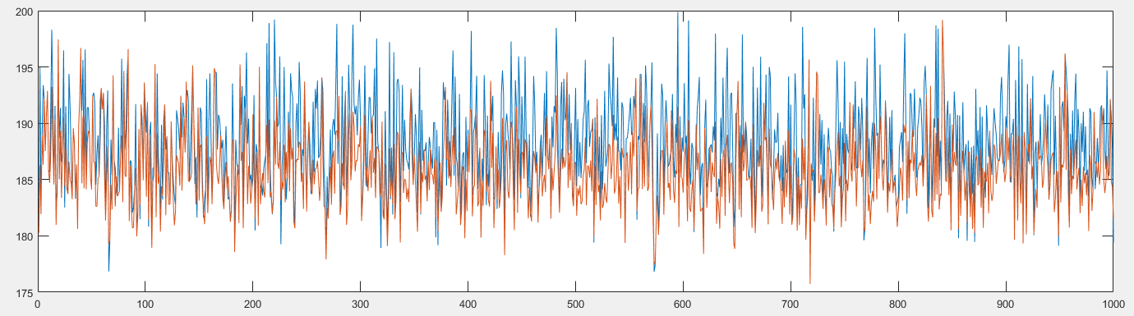

Basic ServiceTime=Uniform(450,500)

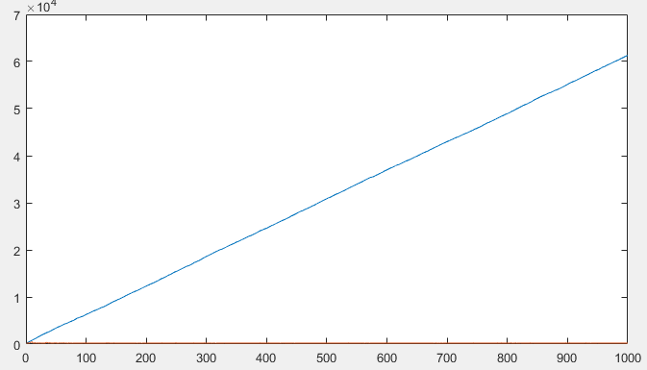

Uniform(500,560)

Inter-arrival rate of Uniform(70,130)

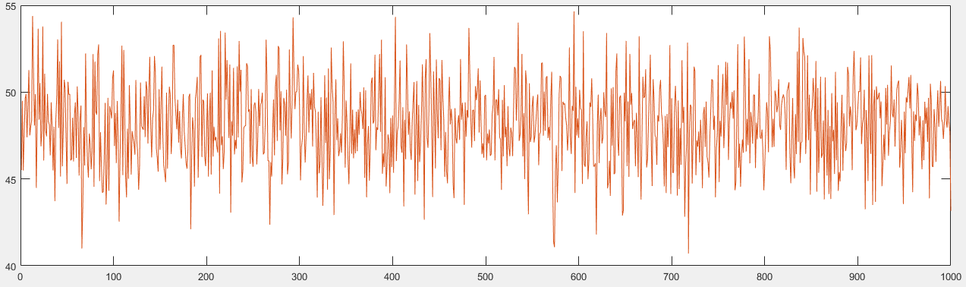

Basic ServiceTime=Uniform(100,150)

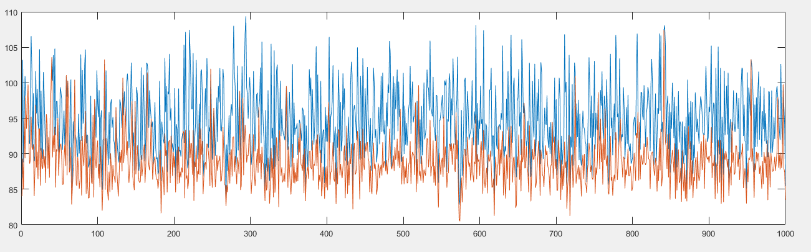

Basic ServiceTime=Uniform(200,250)

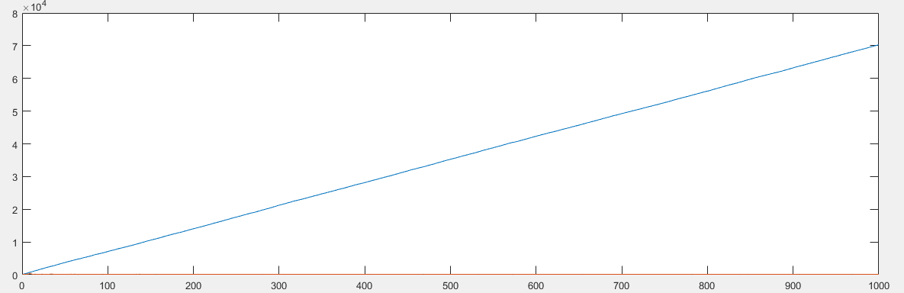

Basic ServiceTime=Uniform(250,300)